How to Search For Emails in Webmail Pro
1. Solve your “Now where did that email go?” problems today! Click on Search in the upper left-hand corner of your webmail screen.
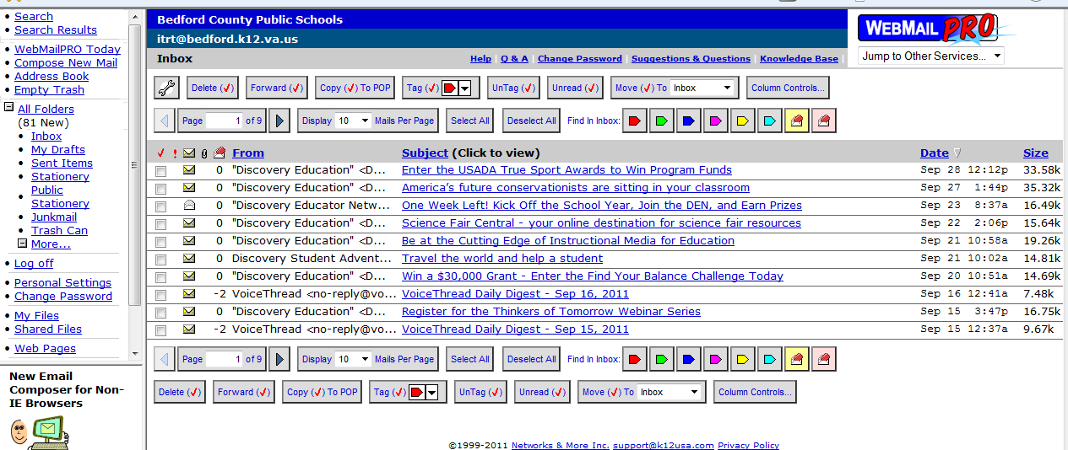
2. Type into the “Search for” box the desired email address (only the portion of the address before the @ is needed), or type in the words in the subject line of an email.
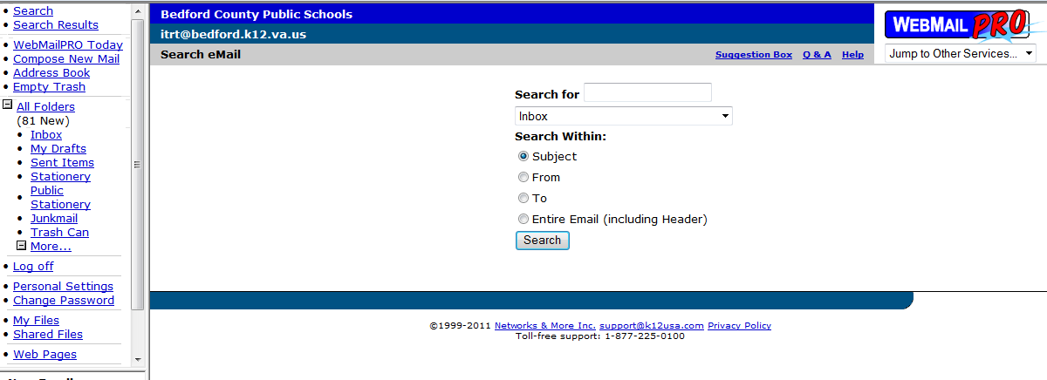
3. If the email you are searching is in a folder other than Inbox, click on this black drop down arrow to select a different folder.
2dkjkdfjkfjdkjfdk
4. Click on:
--“Subject” if searching specific words in the subject line of an email
--“From” for emails from the person
--“To” for emails to that person
--“Entire Email (including Header”): this takes the longest amount of time
5. Click on “Search” and voilὰ! Your search results will appear.

