How to create groups in PowerTeacher Gradebook
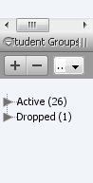
- Open your gradebook.
- Select + sign under STUDENT GROUPS

- Select Add Group Set from drop down menu – Name the group set (ex. Stoplight)
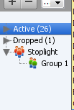
- Rename Group 1 by selecting “Group 1” (it will highlight blue), right click and select Edit from dropdown menu. Rename group (ex Green ).
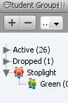
- To add a second group, select Group Set name (ex Stoplight)- It will highlight blue. Right click and select Add Group –Name the group (ex. Yellow)
- Add a third group by repeating step 4. Select group set (ex Stoplight)- It will highlight blue. Right click and select Add Group – Name the group (ex. Orange)
- To add students to groups, select the student name and drag it to the proper group.
- To delete a student from a group, select the student (it will highlight blue), right click and select Delete
- To minimize the groups or group sets, click on the arrow to the left of the group or group set.
- If you click on group name, all students in that group will highlight on the main student list.
- To delete a group, select the group name, right click and select Delete
- To delete a Group Set, select the group set name, right click and select Delete

